Module 6

Assignment 6.3
Course: CSD402-340A Java for Programmers
Prepared By: Mirach Erkol
Date of Report: 2/14/2025

https://github.com/Mikey5007/biosite.git
6.3 Assignment: Linked Repository
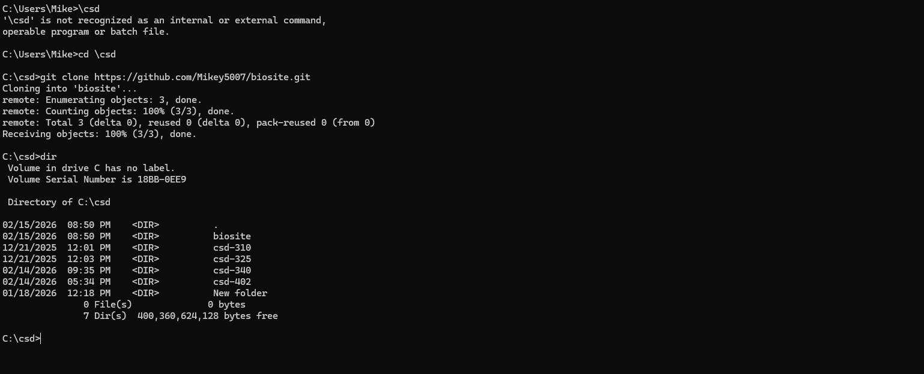
6.3 Assignment: Validated CSS
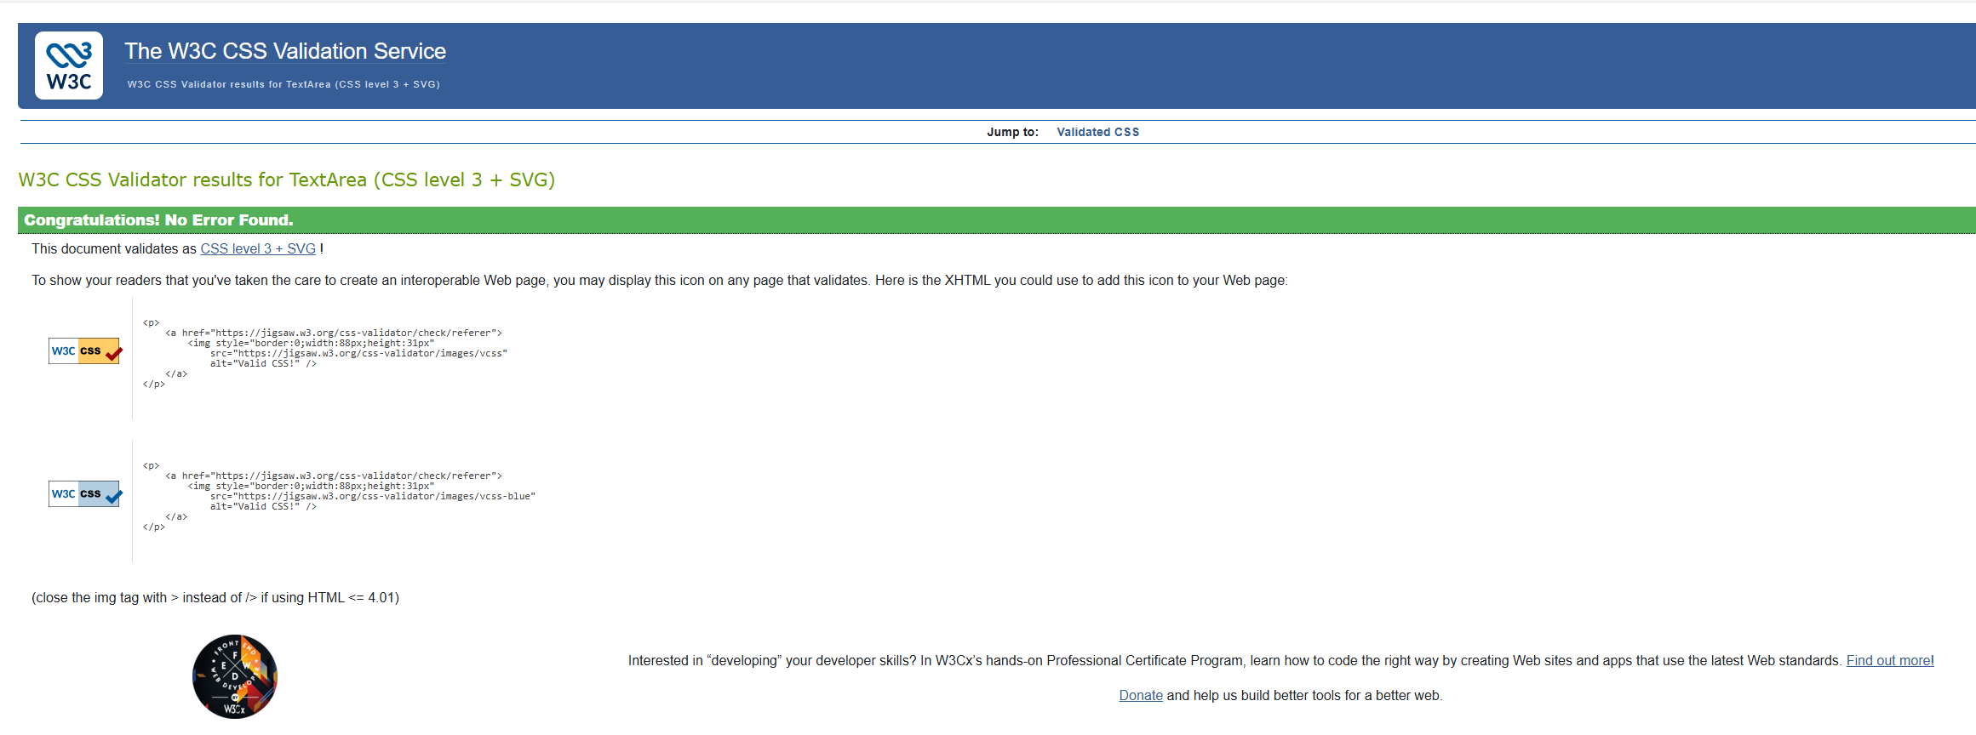

References:

https://github.com/Mikey5007/biosite.git

